SESSION 8 ASSIGNMENT 3

Transactions in Hive

set hive.support.concurrency = true;

set hive.enforce.bucketing = true;

set hive.exec.dynamic.partition.mode = nonstrict;

set hive.txn.manager = org.apache.hadoop.hive.ql.lockmgr.DbTxnManager;

set hive.compactor.initiator.on = true;

set hive.compactor.worker.threads = 2;

CREATE TABLE college(clg_id int,clg_name string,clg_loc string) clustered by (clg_id) into 5 buckets stored as orc TBLPROPERTIES('transactional'='true');

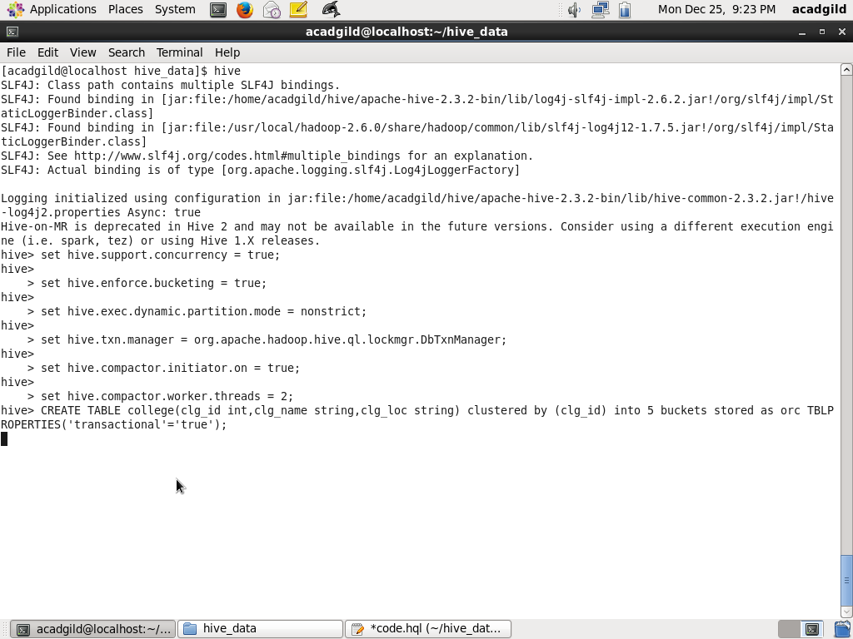

INSERT INTO table college values(1,'nec','nlr'),(2,'vit','vlr'),(3,'srm','chen'),(4,'lpu','del'),(5,'stanford','uk'),(6,'JNTUA','atp'),(7,'cambridge','us');

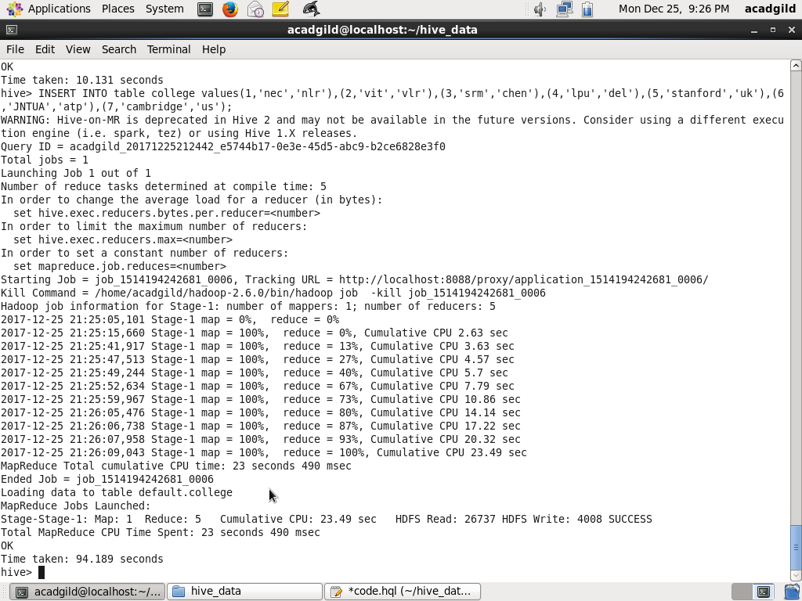

//We cannot update value of column which are used for bucketing

UPDATE college set clg_id = 8 where clg_id = 7;

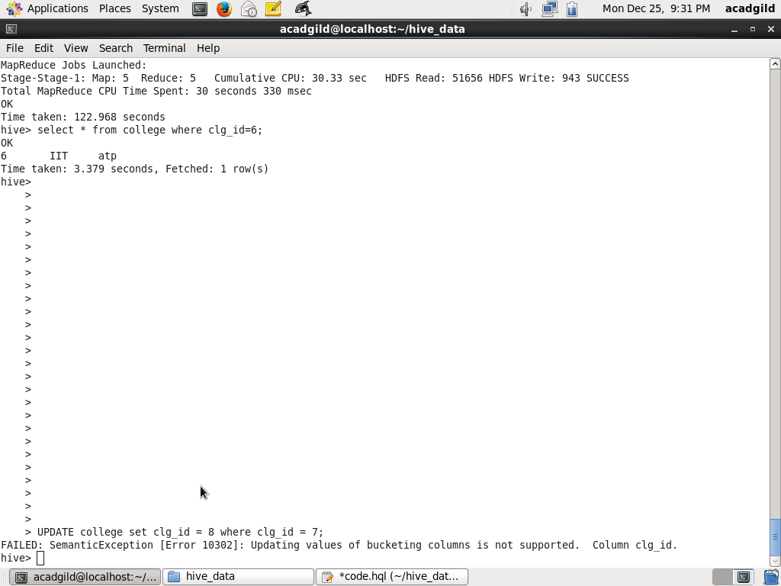

//Update statement is used for updating value of column/cell.

UPDATE college set clg_name = 'IIT' where clg_id = 6;

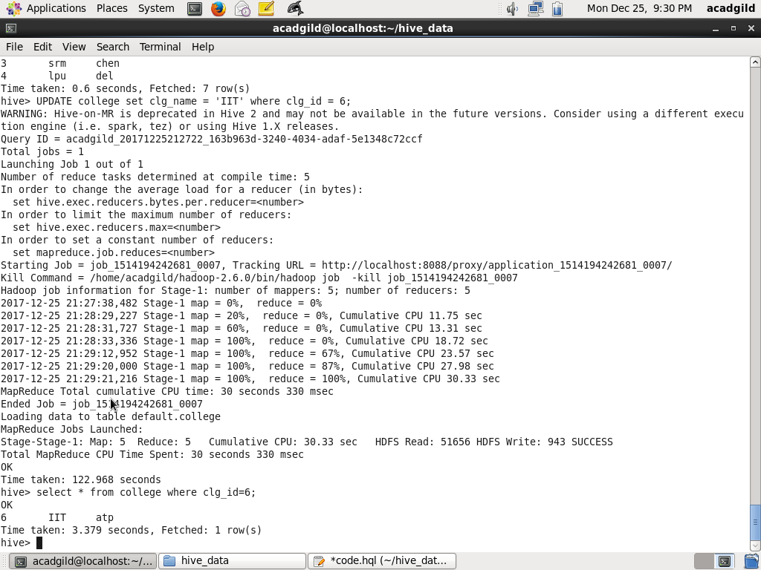

delete from college where clg_id=5;

